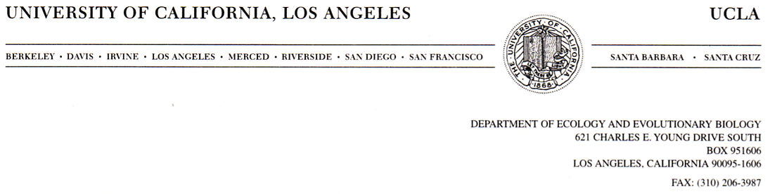

DEPARTMENT OF ECOLOGY AND EVOLUTIONARY BIOLOGY

621 CHARLES E. YOUNG DRIVE SOUTH

BOX 951606

LOS ANGELES, CALIFORNIA 90095-1606

DEPARTMENT OF ECOLOGY AND EVOLUTIONARY BIOLOGY

621 CHARLES E. YOUNG DRIVE SOUTH

BOX 951606

LOS ANGELES, CALIFORNIA 90095-1606

Dec 07 2018

Daniel Bolnick, Editor in Chief

*The American Naturalist*

Dear Dr. Bolnick,

Please consider our submission of a regular article to *American Naturalist* titled, “Mechanisms underlying higher order interactions: from quantitative definitions to ecological processes”. It addresses a core conceptual issue in the structure of ecological communities and will be of broad interest to the readership of *AmNat*.

Ecologists are increasingly aware of the potential for higher order interactions to shape communities of more than two species1,2,3. However, recent papers provide inconsistent definitions of higher order interactions and offer few explanations for how higher order interactions might emerge in the first place. In our manuscript we address both of these issues.

First, we develop a general definition of higher order interactions that focuses on multispecies competition and distinguishes higher order interactions from non-linear density dependence. Our definition leads to a practical set of procedures for detecting higher order interactions in empirical data. Next, we build a simple mechanistic model of resource competition among three annual plant species and simulate competition in two and three species communities. We then attempt to detect higher order interactions in the per capita growth data generated by the simulations. This example shows how the right experimental data can be used to detect higher order interactions and sheds light on the traits and environments that are likely to generate them. We believe our work will be widely cited as more ecologist work to detect higher order interactions in natural communities.

We have no competing interests to declare, and none of the data or results reported in the manuscript have been published or submitted elsewhere.

Sincerely,

Andrew Kleinhesselink on behalf of co-authors

Grilli, J., G. Barabás, M. J. Michalska-Smith, and S. Allesina. 2017. Higher-order interactions stabilize dynamics in competitive network models. Nature 548:210–213.

2 Levine, J. M., J. Bascompte, P. B. Adler, and S. Allesina. 2017. Beyond pairwise mechanisms of species coexistence in complex communities. Nature 546:56–64.

3 Mayfield, M. M., and D. B. Stouffer. 2017. Higher-order interactions capture unexplained complexity in diverse communities. Nature Ecology & Evolution 1:0062.